**Customers Data Storage and Retrieve Data from Database**

**1. Introduction**

* Save new customers data in database and fetch all the customers in table format in UI
* Benefit is we can add new customers data and we can see all customers available in database.

**2. Expected List of Features**

* Dynamic web site with a cable of handling heavy load for fetching data and saving data into database.

**3.Results of Project**

**Customers Details**

This page is used to see all the customers details on UI.

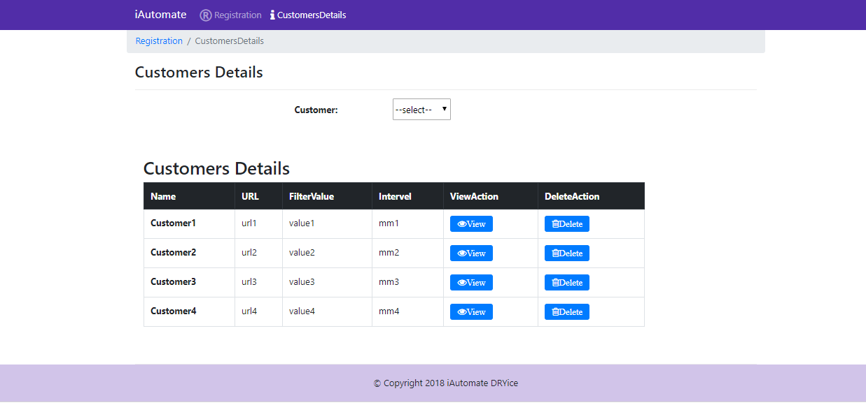

**New Registration**

This pages is used to save new customers data in database

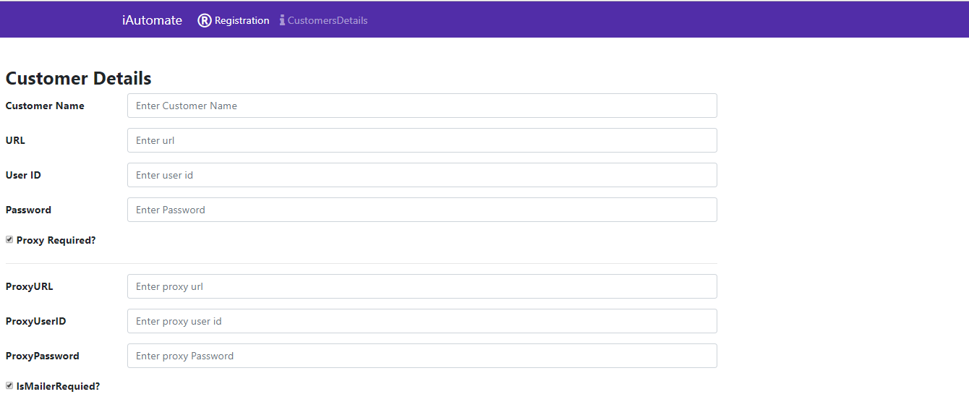

**Database**

This is the database where Customers data is saved and Fetched .

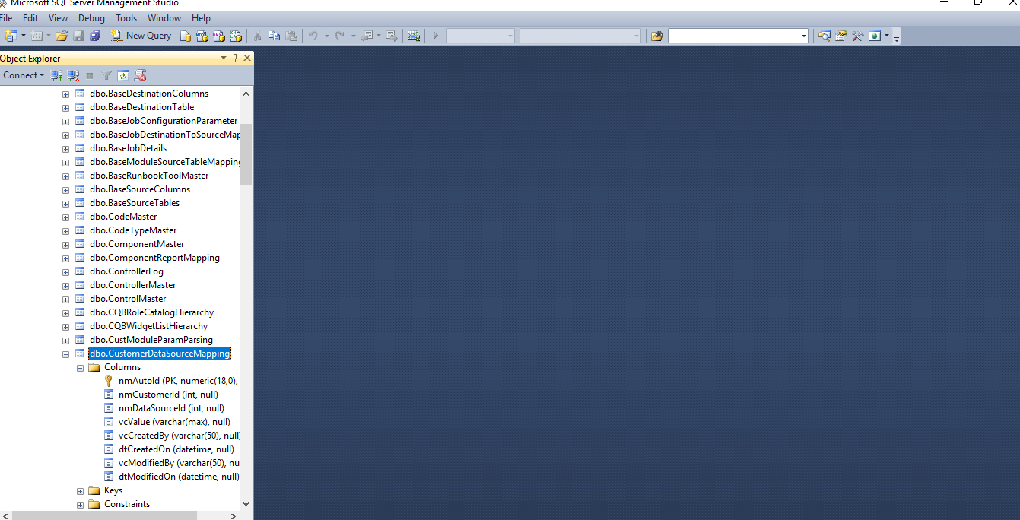

**4. References**

<https://www.kompulsa.com/how-to-get-data-from-an-api-and-save-it-using-node-js-and-mongoose/>

https://www.w3schools.com/nodejs/nodejs_mongodb_insert.asphttps://www.quora.com/How-do-send-data-from-textbox-of-html-to-database-using-node-js

https://mdbootstrap.com/components/bootstrap-checkbox/

http://getbootstrap.com/docs/4.0/components/forms/

<https://getbootstrap.com/docs/3.3/components/>